名前 年 月 日

JAPANESE STUDENTS.
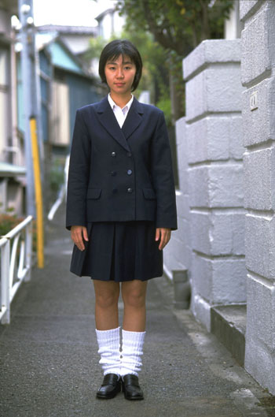

- What do many Japanese students wear to school?
a. regular clothes b. uniforms
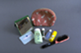

- How do many Japanese students go to school?
a. by bicycle b. by bus

- Where do many Japanese students eat lunch?
a. in the classroom b. in the cafeteria

- When do many Japanese people wash their hands?
a. when they get home b. when they get home and before eating
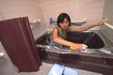
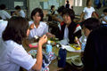
- Do many Japanese students brush their teeth at school?
a. yes, after lunch b. no, they don’t

- When do many Japanese people take a bath?
a. in the morning b. at night

COMPARISONS

- Name some things you think are the same for Japanese and American students.
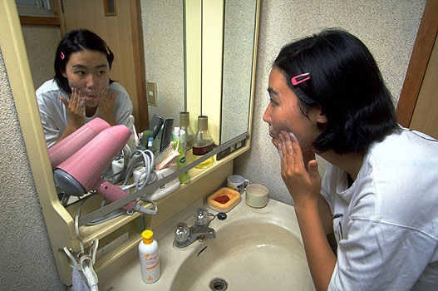

- Name some things you think are different between Japanese and American students.

