Task A: Read the texts in Japanese and answer the questions below.
Retell the story to the rest of the group.
ダンスぶのこうえん Text 3
9月に ぶんかさいが ありました。わたしは 高校2年生です。だから、さいごのぶんかさいでした。
わたしのクラスは、「トッポギ」と「タピオカ」を うりました。オリジナルキャラクター「トッポくんとタピちゃん」をモチーフに うりました。 （Ｏｒ，わたしのクラスは、食べものを うりました。）

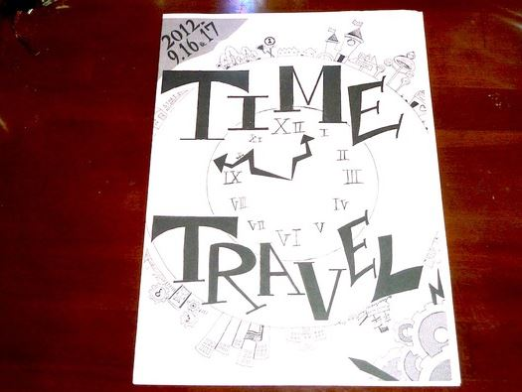
それから、わたしはダンスぶです。ダンスぶの ステージは、ぶんかさいで 一ばん にんきがあります。じゅんびは、とてもたいへんでした。でも、みんな、がんばりました。ステージは とてもすてきでした。わたしはとても、しあわせでした。

しゃしんは、ダンスぶの パンフレットです。

ライター：ちか
高校3年生です。ダンス部でした。マンガが大好きです。

Vocab:
ダンスぶの Dance Club’s こうえん Performance さいごの Last ぶんかさい Cultural festival クラス Class トッポギ Korean sweets タピオカ Tapioca drinks うりました sold
オリジナルキャラクター Original Character モチーフに as motif ステージ Stage
にんきがあります is popular じゅんび preparation がんばりました worked hard
たいへん troublesome しあわせ happy しゃしん photos,
パンフレット pamphlet マンガ Manga

Q1: What is this topic about?
Q2: When was this held?

Q3: What is the year level of this author?

Q4: Why is this the last event for her?

Q5: What does わたしのクラスは 「トッポギ」と「タピオカ」をうりました。Mean?

Q6: Which club does she belong to?
Q7: Describe what she did on the day? How did she feel at the end? Why?

Task B: Read the text aloud in Japanese and record your voice.
ダンスぶのこうえん
Tasks:
Read the texts in Japanese with Task A student.
Read the text aloud and record your voice on the PPT or other file.
Make up a summary as below:
Name
Date of the event
Who is involved?
What is happening?
How is it done?
Any costume or uniform to be worn
Task C: Read the text in English and further research on this topic.
ダンスぶのこうえん
Tasks:
1. Visit the website called くりっくにっぽん, and find this blog post in English.
Read the text in English (see site below) and then retell the story to the rest of the group members.
http://www.tjf.or.jp/clicknippon/en/365/event/culture-festival/culture-festival.php
This site shows the exact translation of an authentic blog. So this will give more detailed information than the Japanese texts. You need to confirm the translation of what the Task A and B students have done.
2. Research this topic further to find relevant images, icons or words to add to the presentation and forward them to the person with Task D.
Task D: Put all information together and present it to the class.
ダンスぶのこうえん
Tasks:
1.Listen to the Japanese and English translations and then collect all the data from the other members and create a presentation file. This could be PowerPoint, movie, comic strip or poster. The presentation file should have some of the Japanese dialogue you have learnt, images, and some information in English.
2. Present it to the class.
Task A: Read the texts in Japanese and answer the questions below.
Retell the story to the rest of the group.
京都･奈良に行きました Text 4
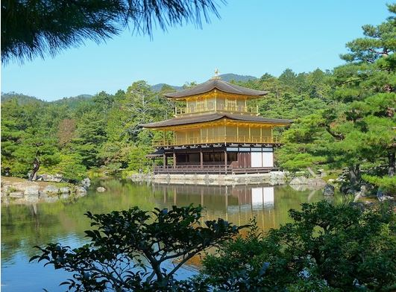
10月に、しゅうがくりょこうに行きました。
京都と、奈良に行きました！日本のぶんかが いっぱいです。

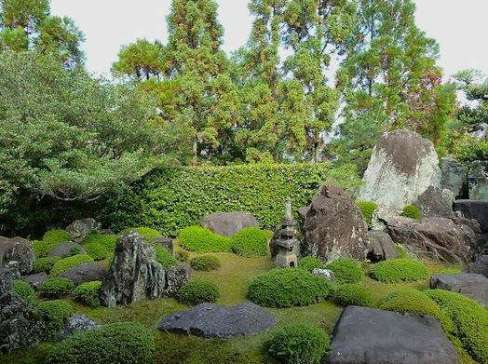

ゆうめいなおてらや、おしろを 見ました。
おてらのにわが、すごくきれいでした。だから、
しゃしんを とりました。

「よふかし」をして、先生にしかられました。でも、とても いい おもいでです。

ライター：ちか
高校3年生です。ダンス部でした。マンガが大好きです。

Vocab:
しゅうがくりょこう School Trip ぶんかculture いっぱい a full of ~, many
おしろ castle おてらtemple きれいでした was pretty しゃしんphotos とりました took
「よふかし」 Stay up late Somethingをして did something and … しかられました been scolded
おもいで memory

Q1: When was the School trip?
Q2:Where did they go on this school ?
Q3: Why do you think they went there?
Q4: What did they see? What does しゃしんを とりました mean?

Q5: What did they do to get scolded by the teacher?
Task B: Read the text aloud in Japanese and record your voice.
京都･奈良に行きました
Read the texts in Japanese with Task A student.
Read the text aloud and record your voice on the PPT or other file.
Make up a summary as below:
Name
Date of the event
Who is involved?
What is happening?
How is it done?
Any costume or uniform to be worn

Task C: Read the text in English and further research on this topic.
京都･奈良に行きました
Tasks:
1. Visit the website called くりっくにっぽん, and find this blog post in English.
Read the text in English (see site below) and then retell the story to the rest of the group members.
http://www.tjf.or.jp/clicknippon/en/365/event/school-trip/school-trip.php
This site shows the exact translation of an authentic blog. So this will give more detailed information than the Japanese texts. You need to confirm the translation of what the Task A and B students have done.
2. Research this topic further to find relevant images, icons or words to add to the presentation and forward them to the person with Task D.
Task D: Put all information together and present it to the class.
京都･奈良に行きました
Tasks:
1.Listen to the Japanese and English translations and then collect all the data from the other members and create a presentation file. This could be PowerPoint, movie, comic strip or poster. The presentation file should have some of the Japanese dialogue you have learnt, images, and some information in English.
2. Present it to the class.
Task A: Read the texts in Japanese and answer the questions below.
Retell the story to the rest of the group.
がくねんまつテスト Text 5
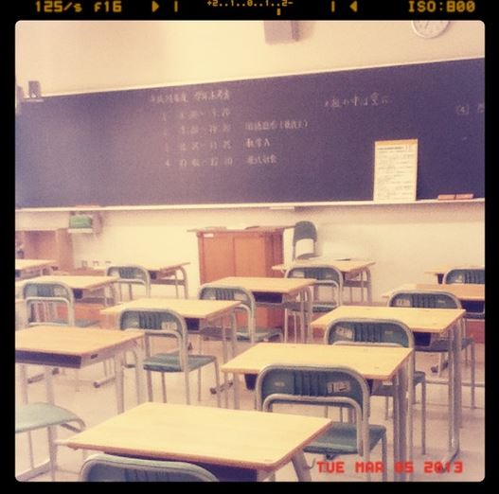
わたしの高校では、3月5日から8日まで がくねんまつテストがありました！

わたしのかもくは、こく語、こてん、
すう学Ⅰ、すう学Ａ、えい語Ⅰ、えい語α、
かがく（りか）、しゃかい、ちり、
オーラルコミュニケーション、ほけんたいいくです。

ぜんぶで 11のかもくを べんきょうします。

テストの一しゅうかんまえから、ぶかつは きんしです。
わたしは かがく（りか）と すう学が にがてです。だから、とてもしんぱいです(´・_・`)

ライター：ｎｕｔｓ
高校2年せいです。ぶかつは チアリーディングぶです。
おんがくが好きです。いま、フィンランドの学校で、べんきょうします。

Vocab:
がくねんまつテスト
こてん
＊かがく
ちり
オーラルコミュニケーション
ほけんたいいく
一しゅうかんまえ
きんし
しんぱい

Task B: Read the text aloud in Japanese and record your voice.
がくねんまつテスト

Read the texts in Japanese with Task A student.
Read the text aloud and record your voice on the PPT or other file.
Make up a summary as below:
Name
Date of the event
Who is involved?
What is happening?
How is it done?
Any costume or uniform to be worn
Task C: Read the text in English and further research on this topic.
がくねんまつテスト
Tasks:
1. Visit the website called くりっくにっぽん, and find this blog post in English.
Read the text in English (see site below) and then retell the story to the rest of the group members.
http://www.tjf.or.jp/clicknippon/en/365/event/exam/post-17.php
This site shows the exact translation of an authentic blog. So this will give more detailed information than the Japanese texts. You need to confirm the translation of what the Task A and B students have done.
2. Research this topic further to find relevant images, icons or words to add to the presentation and forward them to the person with Task D.
Task D: Put all information together and present it to the class.
がくねんまつテスト
Tasks:
1.Listen to the Japanese and English translations and then collect all the data from the other members and create a presentation file. This could be PowerPoint, movie, comic strip or poster. The presentation file should have some of the Japanese dialogue you have learnt, images, and some information in English.
2. Present it to the class.

Task A: Read the texts in Japanese and answer the questions below.
Retell the story to the rest of the group.
あきのスポーツたいかい

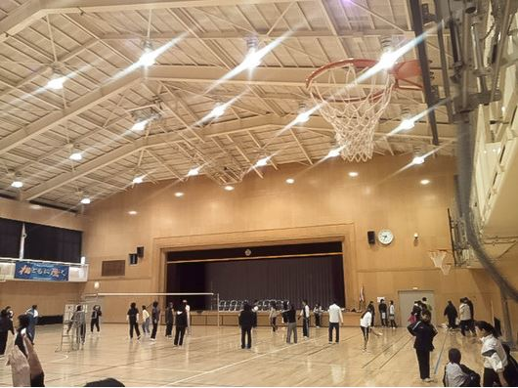
11月のさいごの日曜日に、わたしのまちの スポーツたいかいがありました。いいてんきでした。やきゅうと、バレーボールをしました。

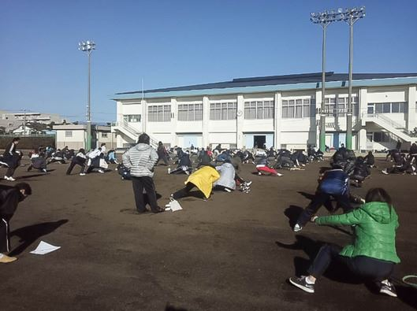

いつもは、みんな、いそがしいです。あまり、あいません。
スポーツたいかいで、いっしょに、スポーツをしました。ともだちになりました。
だから、スポーツたいかいは、とても たいせつな イベントです。
ライター：みお
大学2年生です。どくしょと、おんがくが好きです。One Direction が 大好きです。中国語と、えい語を べんきょうします。

Vocab:
さいごの
きんじょ
いいてんき
やきゅう
あいません
～になりました
たいせつな

Task B: Read the text aloud in Japanese and record your voice.
がくねんまつテスト

Read the texts in Japanese with Task A student.
Read the text aloud and record your voice on the PPT or other file.
Make up a summary as below:
Name
Date of the event
Who is involved?
What is happening?
How is it done?
Any costume or uniform to be worn
Task C: Read the text in English and further research on this topic.
がくねんまつテスト
Tasks:
1. Visit the website called くりっくにっぽん, and find this blog post in English.
Read the text in English (see site below) and then retell the story to the rest of the group members.
http://www.tjf.or.jp/clicknippon/en/365/event/exam/post-17.php
This site shows the exact translation of an authentic blog. So this will give more detailed information than the Japanese texts. You need to confirm the translation of what the Task A and B students have done.
2. Research this topic further to find relevant images, icons or words to add to the presentation and forward them to the person with Task D.
Task D: Put all information together and present it to the class.
がくねんまつテスト
Tasks:
1.Listen to the Japanese and English translations and then collect all the data from the other members and create a presentation file. This could be PowerPoint, movie, comic strip or poster. The presentation file should have some of the Japanese dialogue you have learnt, images, and some information in English.
2. Present it to the class.

Texts and grouping

Text 1: たいいくさいで ゆうしょうしました(Sports Day 1)

Text 2: クラスでだんけつ (Sports Day 2)

Text 3:ダンスぶのこうえん (Cultural Festival)

Text 4:京都と奈良に行きました(School Trip)

