マスクと手洗い
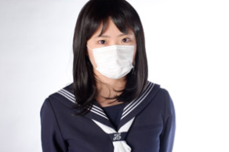
１Wearing a mask
Since the coronavirus pandemic began, many people around the world have started to wear face masks. In some countries, it's almost expected to wear a mask as a matter of courtesy and safety. Do you have to wear a mask when you go outside?
In Japan, the general public are used to wearing masks, especially in the last 20 years. Japan has been producing masks to protect people from inhaling dust and becoming infected with viruses for over 100 years. Recently, a wide variety of masks have become available. For example, there are close-fitting masks, scented masks, masks designed for summer, and other types.
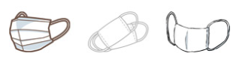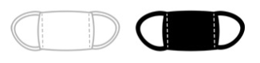
２Make a mask with everyday materials
Have you ever made origami paper crafts? You can make a mask in the same way. Watch the video and answer the following questions.
キッチンペーーマスクhttps://www.youtube.com/watch?v=c7-oE_xBDSA
- What materials do you need? _________________________________________________
- What is the first thing you need to do? __________________________________________
- What is the second thing you need to do? _______________________________________
- What is the last thing you need to do? __________________________________________
- Now, let’s make a mask. Make sure your hands and desk are clean. First, draw a picture or write a message on the paper towel you are using. What kind of message would you like to write? How about a positive word or expression, like がんばろう！(Let’s do our best!)
Once you finish drawing or writing your message, watch the video again and make your own mask. Once it’s done, wear it and show it to your family, teachers, and friends. You can make masks for your family members, too! Note: Wearing a handmade mask does not completely protect us from dust and viruses, but it helps to prevent the spread of infection. https://sonaeru.jp/goods/handiwork/groceries/g-11/
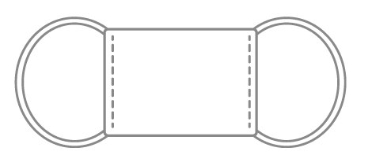
ねこがすき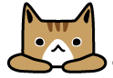
がんばろう！
3 Wash hands effectively
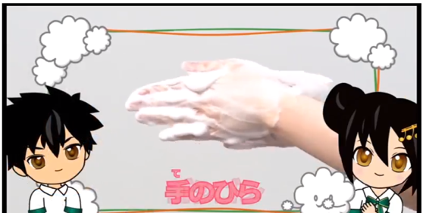
Along with wearing a mask, washing your hands is another important step to stop infections from spreading. But how should we wash our hands? First, let’s watch the video. http://www.pref.tochigi.lg.jp/c05/tib/5ch/kenko/024.html

- Number the actions in the correct order as seen in the video. The first one and the last one have been done for you. You can watch the video again if you like.
1 | Wet both hands (and turn off the tap). おをかけましょう 両手にしっかりと
 | Wash your thumbs. 親指 キュッキュキュー
 | Wash the tips of your fingers. 指先 ゴシゴシ
Rinse the lather off with running water (and turn off the tap).
おで しっかり 流しましょう
 | Wash between your fingers. 指のあいだも わすれずに
 | Using soap to lather up your hands. 石けんって あわあわ ブクブク てよう
 | Wash your palms and the back of your hands. 手のひら ゴシゴシ 手の ゴシゴシ
 | Wash your wrists. 手首を クルクル よくあらおう
9 | Dry your hands with a clean handkerchief. きれいな ハンカチで 手をふこう
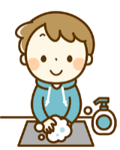
- How is this different from the usual way you wash your hands?
___________________________________________________
___________________________________________________
- Write the meaning of each after watching the video.
手 |  | 親指
手のひら |  | 指先
手の甲 |  | 手くび
指 |  | (お)水
- This time, write the correct word for each part of the hand in Japanese. You can use hiragana.
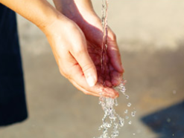
For an online quiz, go to https://www.studystack.com/studyslide-3230552
fingers
fingertips
thumb
back of the hand
palm
wrist
- Watch the video again. Did you hear the following words in the song? Match each word to the correct action, and write the answer below each word.
1 | 2 | 3 | 4 | 5
ざぶざぶ | あわあわブクブク | ゴシゴシ | キュッキュッ | クルクル
Lathering up the soap | Washing the wrists with a turning motion | Wetting the hands with water | Scrubbing hands and fingers | Washing the thumbs until squeaky clean
For an online quiz, go to https://www.studystack.com/quiz-3230554
- These words are called onomatopoeias, and they are used to imitate sounds. Japanese onomatopoeias are also used for things or actions that don't normally make any noise.
- What have you noticed about these Japanese onomatopoeias?
- Have you seen other Japanese onomatopoeias before?
- Using the words and expressions you learned above, make a bilingual poster about hand washing. You may refer to the examples below if you like.
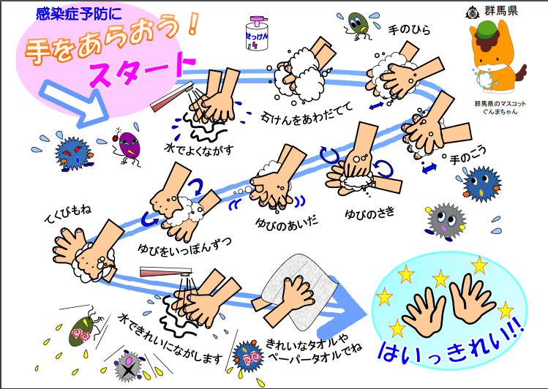 | 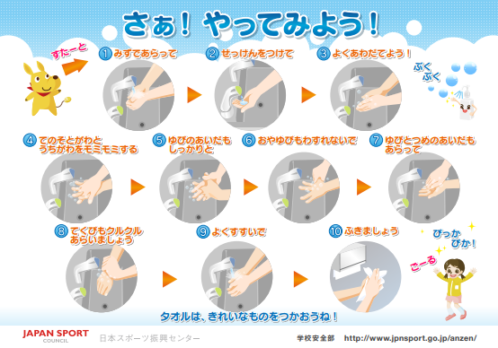
https://www.pref.gunma.jp/02/d2900167.html | https://www.jpnsport.go.jp/anzen/Tabid/1716/Default.aspx

Put the poster up in a place where you wash your hands so that it reminds you and your family how to do it in an effective way.
Let’s watch Arashi, a popular Japanese idol group, dance and show the proper way to wash your hands. https://www.youtube.com/watch?v=jSM0h8VPSZk
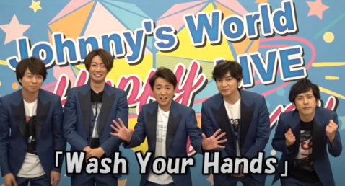

Illustrations: http://gahag.net/?s=%E3%83%9E%E3%82%B9%E3%82%AF

