3. Match each photo to its description.

( 1 ) | ( 2 )
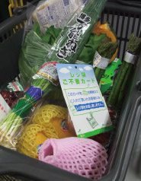 | 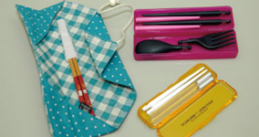
( ) | ( )

( 3 ) | ( 4 )
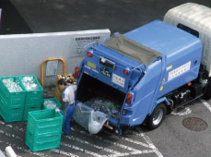 | 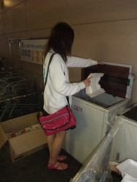
( ) | ( )

a. A recycling truck collects various recyclable resources.
b. People put Rejibukuro fuyo card into their shopping basket just before the check-out to indicate they don’t need plastic bags.
c. People carry ‘my-hashi’ to avoid using disposable chopsticks when eating out.
d. Recycling boxes are located in a corner of the supermarket to collect styrene form trays.

