もったいないばあさん と ふろしきの使い方
Mottainai Baasan and Furoshiki Wrapping
--身近なエコかつどう -Living with the Environment in Mind-
Section A: もったいないばあさん
Have you heard about Mottainai Baasan (Mottainai Grandma)?
Mottainai Baasan appears out of nowhere when we are doing something wasteful, and shows us how to change our habits.
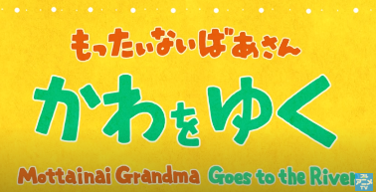
もったいないばあさんのビデオを見て、問題にこたえましょう。Watch the Mottainai Baasan video in Japanese and answer the following questions. https://www.youtube.com/watch?v=Cu1Y7Z3iijM

英語版を見たい人は下のリンクから。If you want to watch the English version to answer the questions, go to https://www.youtube.com/watch?v=p1MYVlIgYnU
- はじめに、何がおこりましたか。どうして男の子は山へつれていかれたのですか。What happened in the first scene? Why was the boy taken to the mountain?

- このビデオによると、川と私達はどんなかんけいですか。右と左をつないで、正しい文をつくりなさい。According to the video, what benefits does the river give us? Complete the sentences by matching the first half and the latter half.
a川のあかちゃんは |  | 1川で水を飲む
bさかなのあかちゃんは |  | 2川の水でそだつ
cどうぶつのあかちゃんは |  | 3山から川にながれる
d木ややお米のあかちゃんは |  | 4川で生まれる

- 大きな川と海では、どんなことがおこっていましたか。What was happening in the big river and the ocean? Explain in Japanese.

- どうやってかいけつすることにしましたか。What was the solution they came up with?

- このビデオでは、水の一生をどのようにしていますか。正しい順番に番号をつけてください。How is the hydrologic cycle (water cycle) explained in the video? Put the sentences in the correct order.
(The first one and the last one have been done for you.)

1 | 川のあかちゃんは、山の上でまれます。
 | そして、にあたためられて、空にのぼって、雲の中に入ります。
 | 小さい川をながれていきます。
 | 川のあかちゃんは、大きい川から、海に入ります。
 | 雲の中から、雨になって、山の上にふります。
 | 小さい川があつまって、大きい川になります。川のあかちゃんは大きい川をながれていきます。
7 | 土の中をゆっくりって、また生まれます。

- ビデオの5:24から5:38までをもう一度見てください。もったいないばあさんが一番伝えたいことを話しています。もったいないばあさんのメッセージをあなたのことばで説明してください。Watch the video from 5:24 to 5:38 again. What is her main message? Explain in your own words.

- Research and discuss what kinds of activities are being done in order to help the environment by individuals, local groups, or enterprises.
Then, write sentences in Japanese to explain the activities. Use ～ために wherever applicable.
Examples:
- 父は、ゴミをへらすために、やさいやくだもののゴミを、コンポストに入れています。
My father puts fruit and vegetable scraps into the compost in order to reduce rubbish.
- 私の学校では、かんきょうのために、ペットボトルとあきかんとかみをリサイクルしています。
At my school, we recycle plastic bottles, empty cans, and paper for the environment.
- オーシャンクリーンアップは、海をきれいにするために、海のプラスチックゴミを、とくべつなきかいを使ってあつめています。
OCEAN CLEANUP is collecting plastic rubbish in the ocean using special machines in order to clean it.
The following sites may be of interest:
- OCEAN CLEANUP
https://theoceancleanup.com/
- “How the oceans can clean themselves: Boyan Slat at TEDxDelft"
(Boyan started OCEAN CLEANUP when he was a high school student.)
https://www.youtube.com/watch?v=ROW9F-c0kIQ
- “Envision Hands turns more than one million bottle caps into prosthetics for children in need”
https://www.newshub.co.nz/home/world/2019/08/envision-hands-turns-more-than-1-million-bottle-caps-into-prosthetics-for-children-in-need.html
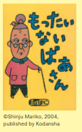
Aboutもったいないばあさん
In the children’s book Mottainai Baasan (Mottainai Grandma), published in 2004 by Kodansha, an elderly obaasan finds people doing wasteful things. Calling out “Mottainai!” she finds many uses for the things they are about to throw away. The series currently appears in newspapers and magazines. Starting in 2008, “Mottainai Grandma’s World Report Exhibition” began touring around the country, explaining the current situation regarding various problems occurring on Earth and the children involved in them.
http://www.mottainai.com/

Section B: ふろしきは昔のエコバッグ？
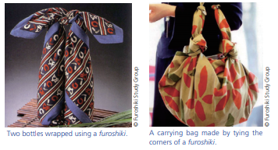
ふろしきは、日本でとても昔(8世紀ごろ)からわれています。
四角いで、使わない時は、小さくたたむことができます。そして、いろいろな大きさや形のものを包むことができます。何度でも使えます。最近は、またふろしきを使う人がふえています。
The Japan Forum magazine TAKARABAKO No20

Furoshiki are used in methods of wrapping or bundling that have a long history in Japan. These square cloths come in different sizes, and can be tied in various ways to carry items of assorted sizes and shapes. Furoshiki can be folded flat when not in use. They are receiving renewed attention because they are both handy and reusable.

ふろしきの使い方をれんしゅうしましょう。70cmx70cm くらいの四角いぬのを使ってください。Let’s practice using furoshiki. Follow the instruction to wrap two bottles with one furoshiki in a way that allows you to carry it like a bag. Use a square cloth such as a scarf (about 70cm x 70cm is best).
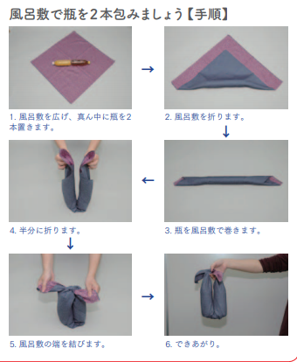
1 ペットボトルかウォーターボトルを二本、まん中におきます。
6 できあがり！
5 ふろしきの
はしを
むすびます。
4 半分に
おります。
3 ボトルを
ふろしきで
まきます。
2 ふろしきを
ななめに
おります。
Section C: かんきょうのR’s、いくつしっていますか
- You probably know that the 3Rs of sustainability stand for “Reuse, Reduce, Recycle.” However, three is not enough. There are many more Rs!
The following website describes 18 Rs of sustainability. (22世紀を生きる君へ－For those who will live in the 22nd century)
https://22nd-century.jp/environment-issues/3r4r5r/
Go to the website and write down all the 18Rs in the chart below. If you have learned Katakana, write them in English and in Katakana, as shown on the website.
Then give points according to what you do or what you don’t do.
- いつもする (I always do this) 3てん
- ときどきする (I sometimes do this) 2てん
- しない (I never do this) 0てん
- これからしようと思う (I will do this from now on) 1てん
 | かんきょうのRs | とくてん (points)
1
2
3
4
5
6
7
8
9
10
11
12
13
14
15
16
17
18
 | Total points

- How many points did you get? Compare with your classmates. Who is the winner in your class?
- Highlight the ones you marked これからしようと思う (I will do this from now on), and write them down on a big piece of paper. Put this up on the wall to remind yourself and other people of new ways to help the environment.
Furigana support on websites
If you need furigana support to read Japanese websites, use ひらがなめがね. Go to http://www.hiragana.jp/en/ and put the URL in the allocated area. Furigana will be added to all the kanji in the website.
For the articles in “Living with the Environment in Mind,” go to
https://www.tjf.or.jp/clicknippon/ja/archive/docs/TB20_E.pdf (English)
https://www.tjf.or.jp/clicknippon/ja/archive/docs/TB20_J.pdf (Japanese)
If you want to learn other ways of using furoshiki, there are many instructional videos available online. The following video is easy to follow: https://www.youtube.com/watch?v=pnLZOj5V-f8

Aboutもったいない
The Japanese word mottainai is said to have originated in Buddhism, to express the grief one feels when an object ceases to be the way it should. Today, the word is used as a kind of protest against waste, and regret that its true value was not put fully to effect. When Wangari Muta Maathai of Kenya visited Japan in 2005, the year after she became the first African woman to receive the Nobel peace prize for environmentalism, she came across with the word mottainai for the first time. Ms. Maathai was deeply impressed by the word, which not only expresses the principle of the 3Rs, but is also filled with compassion, gratitude, and respect for nature and everything in it. She later proposed at the United Nations Commission on the Status of Women held at the U.N. headquarters in New York to embark on a global mottainai campaign to use natural resources more effectively, which led to the beginning of the global-scale mottainai campaign. In Japan, the Asahi Shimbun Company opened a mottainai campaign headquarters, expanding the movement into many different fields with the help of numerous corporations and organizations. Mottainai website: http://mottainai.info.
The Japan Forum magazine TAKARABAKO No20

