マスクと手洗い
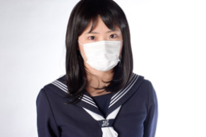
１Wearing a mask
Since the Coronavirus pandemic began, many people around the world have started to wear face masks. In some countries, it's almost expected to wear a mask as a matter of courtesy and safety. Do you have to wear a mask when you go outside?

In Japan, the general public are used to wearing masks, especially in the last 20 years. Japan has been producing masks to protect people from inhaling dust and becoming infected with viruses for over 100 years. Recently, a wide variety of masks have become available. For example, there are close-fitting masks, scented masks, masks designed for summer, and other types.
２Make a mask with everyday materials
Wearing a handmade mask does not completely protect us from dust and viruses, but it helps to prevent the spread of infection. (https://sonaeru.jp/goods/handiwork/groceries/g-11/ )
Choose one from the how-to videos listed below, and make your own original mask.
A: Using cloth  ちょっとむずかしい  Requires a needle and thread | B: Using kitchen paper  かんたん | C: Using a handkerchief  一番かんたん
https://www.youtube.com/watch?v=T1D-CmxxPjo | https://www.youtube.com/watch?v=c7-oE_xBDSA | https://www.youtube.com/watch?v=PGug3ZZPp_k
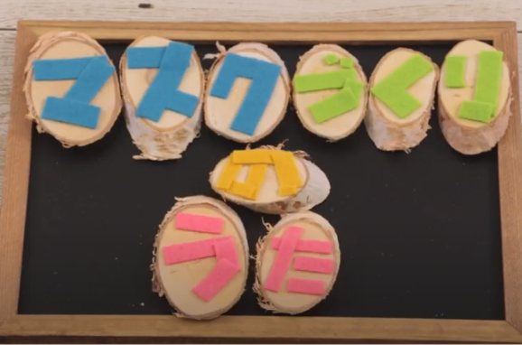 |  | 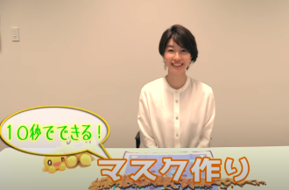
Write up the procedure for making your mask in Japanese.

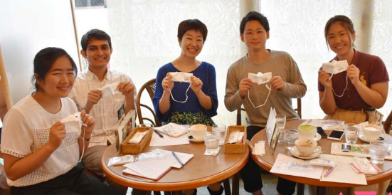
3 The story of Japanese masks
Yukiko Iida is an expert on masks. A group of students from Tokyo International University interviewed Ms. Iida and gained interesting knowledge about masks. You may check the vocabulary and expressions before reading, if you like.

マスクのれきし
むかし、日本では、石炭などの採掘現場がたくさんありました。そこでは、ほこりがいっぱいで、そのほこりをすって死ぬ人がたくさんいたんです。それで、そういうところで働く人たちのためのマスクができました。
20年くらい前までは、とくべつな仕事をしている人だけが、マスクをつけていました。でも、その後、日本の近くでMERSや、鳥インフルエンザや、SARSがありました。そして、花粉症やPM2.5もあって、たくさんの人がマスクをするようになりました*。 *Many people started to wear a mask.
マスクの使われ方** **How masks are used
もともと、体に悪いものをすいこまないため、それから自分が病気の時に、他の人にうつさないために、マスクをつけていました。でも今は、すっぴんをかくすためにマスクをつける人や、マスクをつけたら安心するから、マスクをしている人がふえています。これは、新しいマスクの使われ方だと思います。最近は、かわいいマスク、やわらかいマスク、女の子のマスクなど、いろいろなしゅるいがあります。
みなさんへのアドバイス
いいマスクでも、ちゃんとつけないと効果はありません。まず自分に合ったサイズのマスクを見つけることが大切です。そして、正しくつけて、ウイルスをカットしてください。
Questions
- Highlight all the relative clauses used in the article. Then, write them in the table below. Translate them into English. The first one is done for you.
 | Relative clause in Japanese | English translation
1 | ほこりをすって死ぬ人 | People who die from inhaling the dust
2
3
4
5
- What was the starting point for wearing masks in Japan?
______________________________________________________________________________________________________________________________________________________
- Why have many people started wearing masks in the last 20 years?
______________________________________________________________________________________________________________________________________________________
- Explain how masks are used in Japan these days.
______________________________________________________________________________________________________________________________________________________
- What kind of masks are available now in Japan?
______________________________________________________________________________________________________________________________________________________
- Explain Ms. Iida’s advice.
______________________________________________________________________________________________________________________________________________________
Vocabulary and expressions
石炭 | coal | PM2.5 | fine particulate matter (an air pollutant that is a concern for people's health when levels are high)
採掘現場 | mining site | もともと | originally; initially
ほこり | dust | 体に悪いものをすいこまないため | in order not to inhale something bad for health
すって（すう） | to inhale | 他の人にうつさないために | in order not to transmit to others
死ぬ | to die | すっぴんをかくすために | in order to hide their face when not wearing make-up
とくべつな仕事をしている人 | people who do specialized work (= specialists) | マスクをつけたら安心するから | because they feel at ease when they wear a mask
MERS | Middle East respiratory syndrome (first reported in Saudi Arabia in 2012) | しゅるい | type, variation
 |  | いいマスクでも | even if it’s a good mask
鳥インフルエンザ | bird flu; avian influenza | ちゃんとつけないと効果はありません | unless you wear them properly, there’s no effect
SARS | severe acute respiratory syndrome (recognized at the end of February 2003) | 自分に合ったサイズ | the right size for you
花粉症 | hay fever; allergy to pollen | ウイルスをカットして | block viruses (protect yourself from viruses)
For an online quiz, go to https://www.studystack.com/quiz-3230545

4 Washing hands effectively
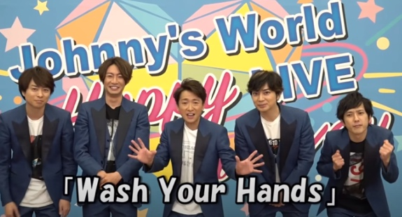
- Along with wearing a mask, washing your hands is another important step to stop infections from spreading. But how should we wash our hands? Let’s watch the members of 嵐, a popular Japanese idol group, show an effective way to wash your hands!
https://www.youtube.com/watch?v=jSM0h8VPSZk
- Around the two-minute mark in the video, Arashi start demonstrating how to do proper hand washing. As you watch them, figure out the meaning of the following words. You may also use your dictionary.
せっけん |  | ゆびさき
手のひら |  | つめ
手のこう |  | おやゆび
ゆび |  | てくび
Hint: Choose the correct word from below.
wrist fingers thumb palms back of the hands fingertips soap nails
- Here are the actions in the order they are done in Arashi’s demonstration. Match the Japanese to the correct English.
1 | Wet the hands with water (and turn off the tap). |  | a | ゆびのさきを あらいます。
2 | Apply soap. |  | b | きれいなタオルでふきます。
3 | Rub the palms together (to make a lather). |  | c | ゆびのあいだを あらいます。
4 | Clean the back of the hands. |  | d | 水で あらいながします。
5 | Clean between the fingers. |  | e | 水で手をぬらします。
6 | Clean the fingertips. |  | f | 手のひらをこすります。
7 | Clean the thumbs. |  | g | てくびを あらいます。
8 | Clean the wrists. |  | h | おやゆびを あらいます。
9 | Rinse off with water. |  | i | 手のこうを あらいます。
10 | Dry with a clean towel. |  | j | せっけんをつけます。
- Create a bilingual poster about hand washing using the words and expressions you learned. You may refer to the examples below, if you like.
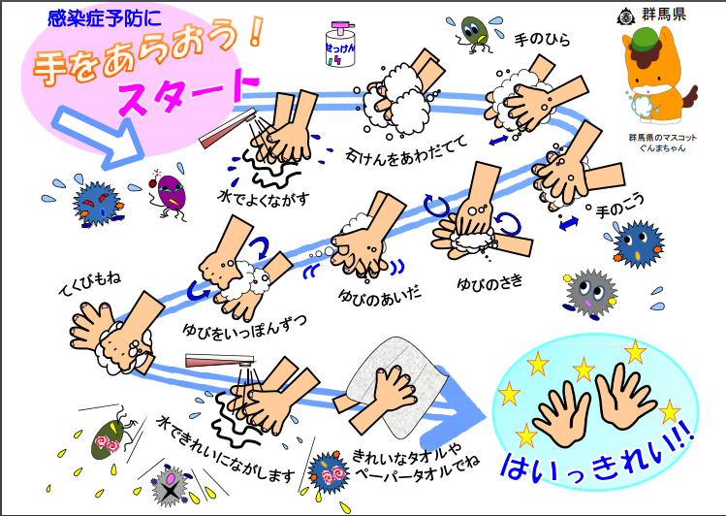 | 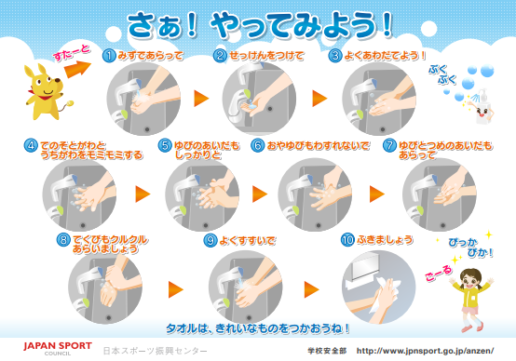
https://www.pref.gunma.jp/02/d2900167.html | https://www.jpnsport.go.jp/anzen/Tabid/1716/Default.aspx

Put the poster up where you wash hands so that it reminds you and your family how to do it effectively.

