What is Emakizushi?
なまえ_____________________
Look at the photos and answer the questions.
1 | 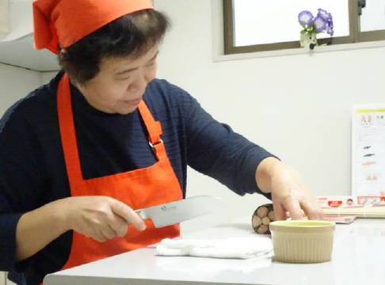 | - This is Ms Nakaya.  What kind of work do you think Ms. Nakaya does?  _______________________________________  - What is Ms Nakaya doing?  _______________________________________  - What do you think Ms. Nakaya is cutting? ______________________________________
2 | 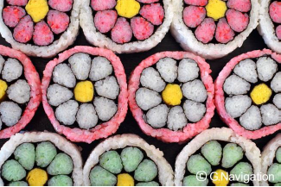 | This is what Ms Nakaya was cutting. What do you think they are? Yes, they are sushi rolls!  - What colours do you see? Circle the ones you see.  ピンク あか あお きいろ くろ しろ  - What ingredients do you think are in this sushi?  ________________________________________  ________________________________________  - What did you think when you saw this sushi? Write what you thought in Japanese. Or choose from the comments below and write them in Hiragana here.  _______________________________________
 | Great! Amazing! Fantastic! | すごい！ | Sugoi!
 | Interesting! | おもしろい！ | Omoshiroi!
 | Cute! | かわいい！ | Kawaii!
 | Pretty! | きれい！ | Kirei!
 | Looks delicious! | おいしそう！ | Oishisou!
3 | Do you eat sushi? How is this sushi and the sushi that you have eaten different?  ___________________________________________________________________________  ___________________________________________________________________________
These artistic rolled sushi is called えまきずし(emakizushi).
Emakizushi means ‘picture-like rolled sushi.’
To make sushi, we use vinegared rice (cooked rice mixed with vinegar, sugar and salt).
Let’s look at different artistic emakizushi on the next page!

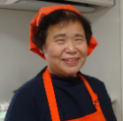

4 | Let's try to figure out what these emakizushi are made of. Which of the following lists of ingredients correspond to which emakizushi? Draw lines from the picture to the corresponding ingredients.
 | Plum blossom roll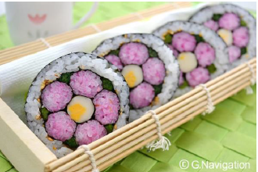 | ‘Four oceans’ roll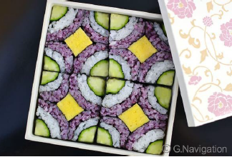 | Rose blossom roll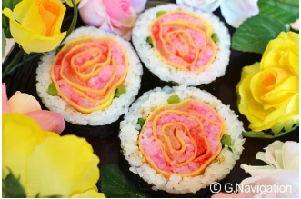

C Five slender rolls of makizushi. One thin strip of cheese. Green vegetables and 2 large sheets of nori.
A Rice, smoked salmon, egg, nori, green vegetables.
B Rice and cucumber rolled sushi. A strip of egg roll. The outside of the square is wrapped with one strip of nori.

5 | Which of these emakizushi would you like to try to make? Why did you choose that one?  ________________________________________________________________________________  ________________________________________________________________________________  If you are interested, watch the videos to see how they are made.  Plum blossom roll  https://www.youtube.com/watch?v=JumAESQwbi0&t=3s  ‘Four oceans’ roll  https://www.youtube.com/watch?v=IknHHHnMpGA  Rose blossom roll  https://www.youtube.com/watch?v=Q7wE2J9r9vo
6 | Let's think up an original emakizushi!  What kind of original emakizushi would you like to make?  Try drawing a design of it in the space on your right.  What ingredients would you use?  If you know the Japanese words for the colours you want, write those colours in Japanese.
7 Choose the month that suits each emakizushi, and write the name of the month under the photos in Japanese. Use kanji if you have learned kanji numbers.
February | April | May | July | October | December
2月or二月 | 4月or 四月 | 5月or五月 | 7月or七月 | 10月or十月 | 12月or十二月

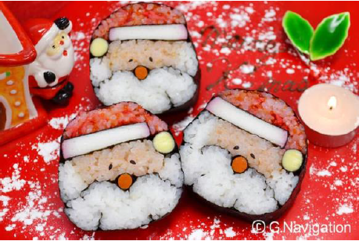 | 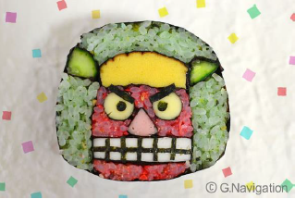
A | B

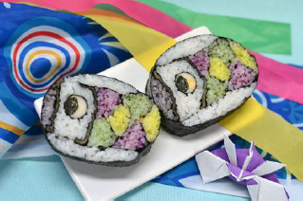 | 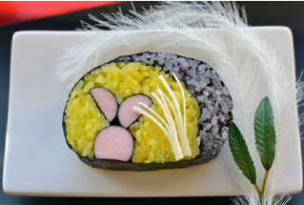
C | D

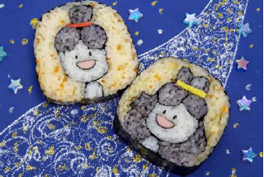 | 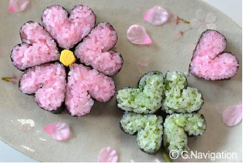
E | F
Ms Nakaya says she hopes family members will enjoy making emakizushi together. In some parts of China, family members make gyoza/pot stickers together. In your country, what kind of food do family members make together?
For online quizzes go to https://www.studystack.com/studyslide-3220354

